Kubarev V.V.
doctor of history, professor
Orthodox Russian Academy

ASTRONOMICAL DATING OF BIBLICAL EVENTS
Summary: The Dating of Biblical events is legendary and weakly correlated with the bright astronomical phenomena described in the Chronicles and which can be identified with modern mathematical tools. According to the author this is due to false traditional chronology, erroneous geographical reference, and deliberate adaptation of phenomena and events by theologians and historians to established stereotypes. The study of ancient Chronicles, Biblical descriptions and his own reconstruction of the history of Ancient Egypt, Ancient Rome and the chronology of monotheistic religions, allowed the author to uniquely link the chronological line of the past to the chain of historical events, characters and celestial occurrence. All astronomical phenomena of ancient Chronicles have found their exact identification with calculated Solar Eclipses and Zodiacs, which instrumentally confirms the correctness of the short chronology of the past and the author's reconstruction of history. Keywords: Bible, Ancient Egypt, Ancient Rome, short chronology, Jesus Christ, Quran, Prophet Muhammad, Solar Eclipses, Zodiacs.
Statement of problem: Accurate astronomical Dating of Biblical events is possible in the case of independent and unbiased research and identification of celestial phenomena with the descriptions of Chronicles and Scriptures. If the author's Dating of key moments of history and celestial phenomena for several thousand years coincides, it is possible to assert a priori that the author's theory is correct. Random coincidence of events and phenomena on such a time horizon is simply impossible.
The analysis of the last of research and publications: The study of Biblical events by identifying astronomical phenomena from the Scriptures with real Solar Eclipses has reached a dead end. There is no explanation for the Solar Eclipse at the time of the Crucifixion of Jesus Christ. The Dating of the Eclipse from the time of Joshua is approximate. It was also not possible to accurately date the Solar Eclipse of the reign of Pharaoh Takelot.
Allocation unresolved before parts of the general problem: There is no exact correlation between the celestial phenomena described in the Bible and the Chronicles of Ancient Egypt and real astronomical events. Errors in the interpretation of Solar Eclipses and Zodiacs with traditional chronology are attributed to a lack of awareness of the chronicle scribes. The author believes that there are precise solutions to identify celestial phenomena with the Scriptures and Chronicles if a short chronology is used.
The purpose of clause: The purpose of this research is to substantiate the author's concept of a short chronology and accurately identify astronomical phenomena in the form of Solar Eclipses and Zodiacs at certain points in the Biblical history and Chronicles of Ancient Egypt.
The basic material: In our research, we adhere to the paradigm of the emergence of modern human civilization in the Volga region about 5500 years ago. This hypothesis was first put forward by Marija Gimbutas in 1956 [1–4]. In the author's research in 2009, we confirmed this theory by linking it to the canvas of historical events of the past [5], and also clarified the chronology and localization of Ancient Egypt and Ancient Rome [6,7]. We also justified a short chronology of Biblical events and monotheistic religions [8]. Our conclusions are confirmed by most of the astronomical phenomena of the ancient Chronicles.
The first historical event is the date of the end of the Trojan War. According to the study [9], the Dating of the war was made based on the description of the Solar Eclipse and the Zodiac. The event corresponds to the return Odysseus to Ithaca and refers to the Total Solar Eclipse of April 16, 1178/1177 BC, a duration of 04:34 minutes at 09:13 UT, 39th Saros, Figure No. 1 [10,11]. Consequently, the Trojan War ended 10 years earlier or in 1188 BC. The difference in one year 1178 and 1177 is caused by different methods of accounting for the zero years. The figure almost coincides with the date of the end of the war 1184 BC from Eratosthenes and Ctesias. We use this Dating in our reconstruction of history [5–8]. The period around 1188–1184 BC is the time of the conquest of Egypt by the Trojans led by Aeneas, who became the Pharaoh Menes (Meni), and the beginning of the history of Ancient Egypt and Ancient Rome, as well as the era of settlement of the children of the Biblical Noah in Eurasia.

Figure No. 1. Total Solar Eclipse over Ithaca in 1178/1177 BC.
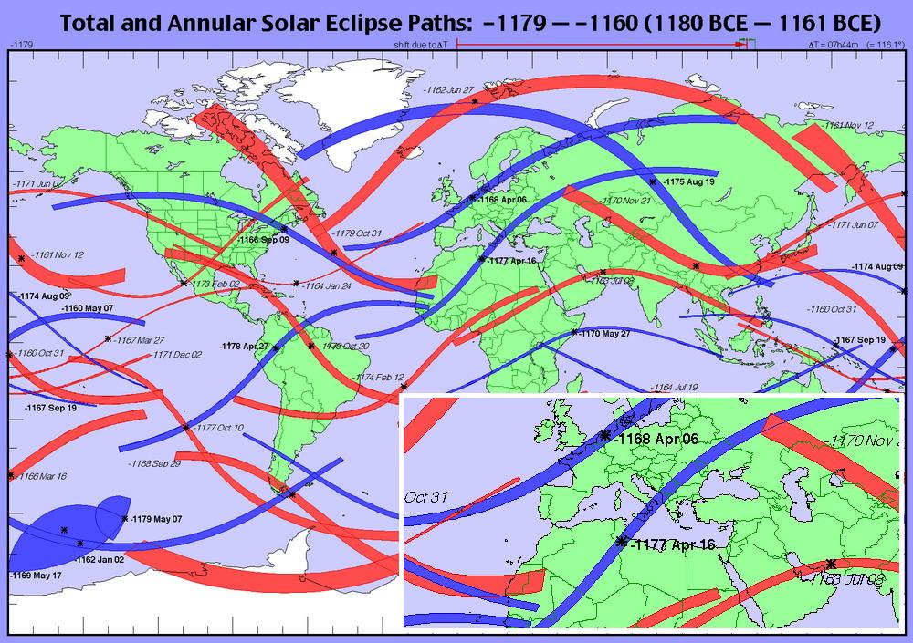

Surprisingly, the Chronicles of Ancient Egypt and the early annals of Ancient Rome contain almost no mention of Solar Eclipses, although the Egyptians were able to calculate these phenomena for many years to come. The lack of data suggests that archaeologists and historians deliberately purged these facts from papyri and artifacts.
The Chronicles of Ancient Rome contain a number of references to Solar Eclipses, but they belong to the later period of the life of the Eternal City. One of the first such phenomena in the history of Rome is mentioned the Solar Eclipse on September 15, 339 BC when the Temple of Juno was consecrated by the historian Livy [12]. It corresponds to an Annular Solar Eclipse on September 15, 339 BC, at 06:53 UT and a duration of 07:41minuts, 58th Saros, Figure No. 2 [10,11]. This Solar Eclipse was well observed only in the Volga region, where according to the author's reconstruction of history, Ancient Rome was located [7], as well as in Central Asia and China. In the Apennines this Eclipse was almost invisible, since it began at sunrise, and the moon's shadow was 1200 km to north of modern Rome.
The next significant Solar Eclipse was to fall on the date of the Crucifixion of Jesus Christ. We have already shown in our work [8] that there is no suitable Solar Eclipse at the time of the Crucifixion of the Savior for the entire period of the I century BC – I century, although it is described in the Gospels, Figure No. 3 [10,11]. We will return to this question later.

Figure No. 2. Annular Solar Eclipse of September 15, 339 BC, 58th Saros.
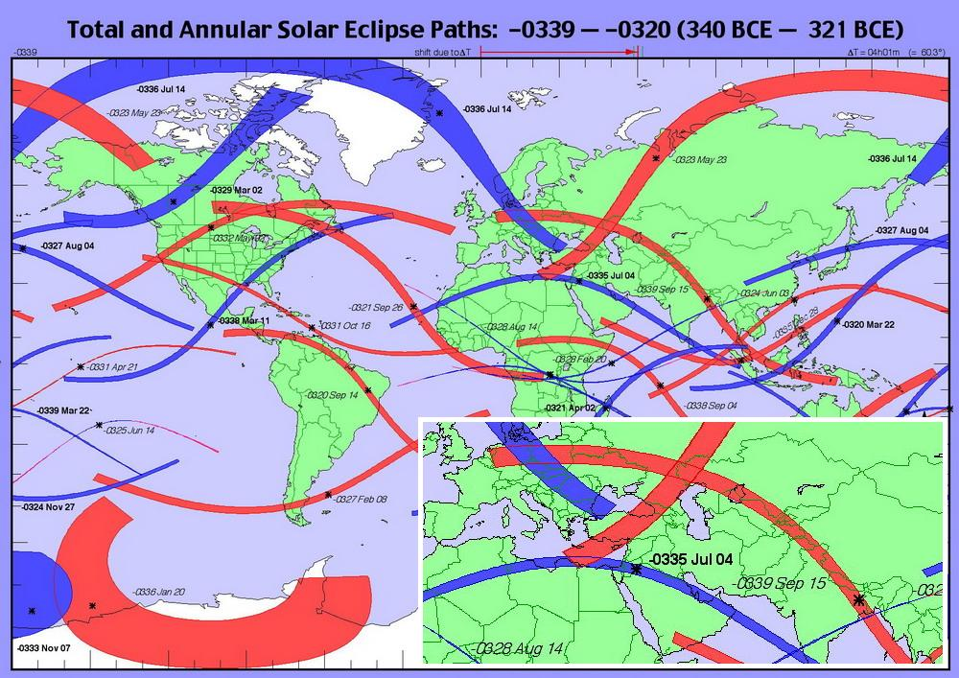

Figure No. 3. Solar Eclipses in 40–20 BC; 20–1 BC; 1–20 and 20–40.
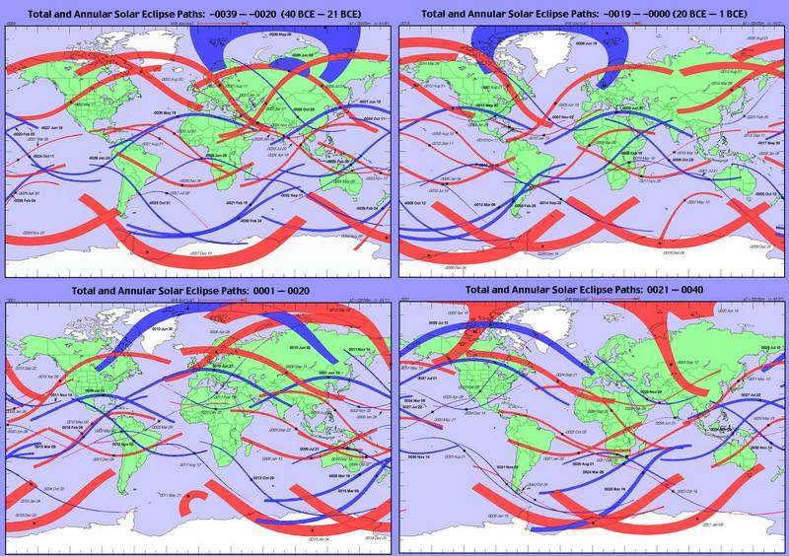

The first mentioned Biblical celestial phenomenon should be considered the Solar Eclipse during the fighting of the Israelites under the rule of Joshua. Adherents of traditional history [13] calculated the date of the phenomenon as October 30, 1207/1206 B.C. Calculations of the date of the battle of the Israelites are compromised by a well-known fact – the Late Bronze Age collapse [14], the era of which exactly falls on the date of the alleged triumph of the Great Israel about 1206 B.C. According to our reconstruction of history and other well-known sources, the catastrophe of the Mediterranean, Egyptian and Mesopotamian civilizations occurred in the period 1250–1200 BC and corresponds to the last World Flood. On this basis, the Dating of the work [13] of the miracles of Joshua becomes insignificant.
Joshua is identified by us with Attila and his acts [5,8], which belong to the middle of the V century. The rise to power of Attila and his conquest of the world took place against the backdrop of a cascade of Solar Eclipses. It all started with an Annular Eclipse on September 29, 433 at 11:07 UT, 99th Saros [10,11]. It was clearly visible in the Black Sea, Volga, Caucasus and Caspian regions – where Attila was located at the beginning of his career. Then follows a period of conquests and battles in the regions of the Balkans, Caucasus, Italy and France – they correspond to the phenomena [10,11]:
– Annular Eclipse of March 17, 443 at 16:09 UT, 85th of Saros.
– Total Eclipse of December 23, 447 at 13:19 UT, 97th Saros.
– Total Eclipse of May 08, 449 at 03:39 UT, 74th Saros.
– Annular Eclipse of February 24, 453 at 15:42 UT, 76th Saros.
– Total Eclipse of May 28, 458 at 11:36 UT, 93th Saros.
In total, there were six Eclipses during the age of Attila, visible in Europe and the Volga region, the last occurring after his death. Three more Eclipses (two Annular Solar Eclipses on 20.09.442 and 10.07.446 and one Total on 10.08.454) of this period occurred in the regions of Central Asia, with a total of 9 Eclipses. There was also an Annular Eclipse over the Atlantic at sunset on 10.10.451, but it was not visible in Europe. It is not surprising that chroniclers and theologians associated the name of Attila – Joshua with a Prophet who could control the Sun and Moon.
The Annular Eclipse of February 24, 453 at 15:42 UT, 76th Saros we can refer to the time of the siege and capture of the Aquileia city. The configuration and external manifestations of this Solar Eclipse almost completely coincide with the Solar Eclipse at the time of the Crucifixion of Jesus Christ on March 18, 1010 at 15:33 UT, 94th Saros, Figure No. 4 and 5 [10,11].
After the settlement of the Roman-Israelites from the Volga region, known in history as the Hunnish invasion or the Migration Period, descriptions of Eclipses and Zodiacs appeared in Egyptian, Roman and Biblical Chronicles. Note that our Dating of historical and Biblical events is based on the discovered chronological shift in the Chronicles of Egypt by 1780 years [6]. At the same time, in the Byzantine chronicle of Theophanes [15], we find a chronological error calculated from Solar Eclipses on average for 8 years. The results of the analysis of Dating of New Rome by Theophanes and Solar Eclipses are summarized in Table No. 1.

Figure No. 4. Solar Eclipses of the era of the conquests of Attila–Joshua.
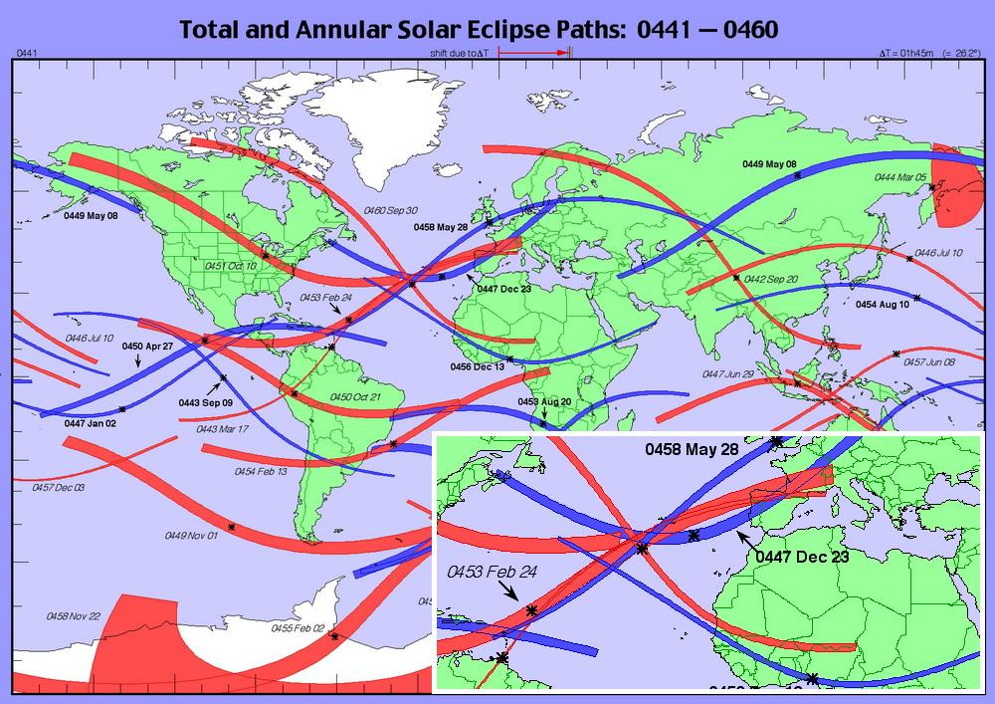

Figure No. 5. Annular Solar Eclipse of the New Testament era on March 18, 1010.
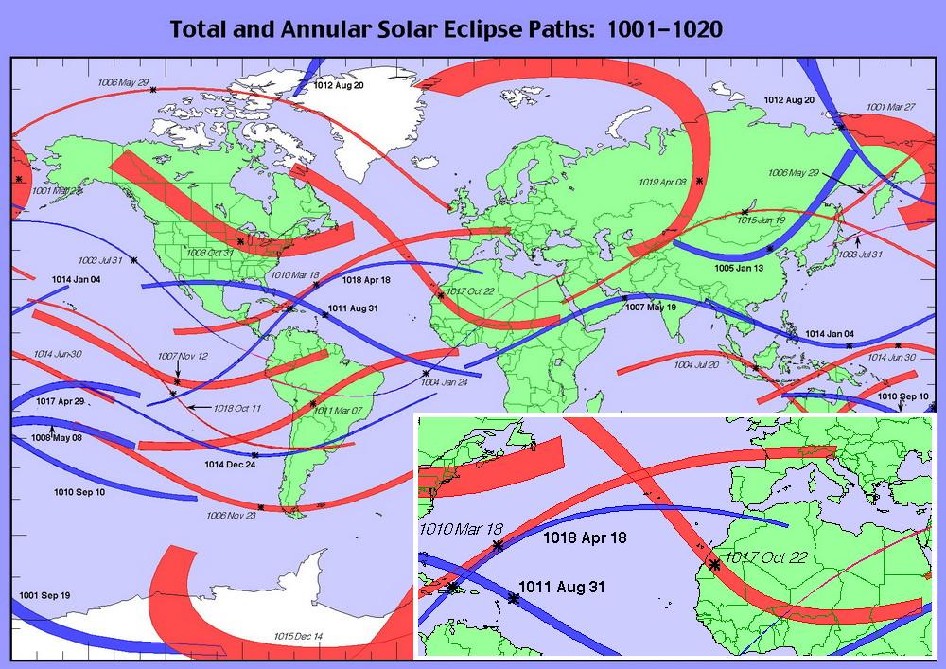

The Table No. 1. Dates of Solar Eclipses on Theophanes [15] and NASA [10, 11].
No. | Theophanes | Information of NASA | Shift, years
1 | July 8, 338  at 15 o'clock | June 6, 346 at 05:38 UT, 91th Saros,  Total Eclipse | 8
2 | 583, in the beginning of spring | March 19, 592 at 9:15 UT, 97th Saros, Total Eclipse | 9
3 | October 5, 636  at 10 o'clock | November 5, 644 at 11:26 UT, 82th Saros, Annular Eclipse | 8
4 | September 5, 686 at 15 o'clock | October 5, 693 at 08:10 UT, 103th Saros, Total Eclipse | 7
5 | August 10, 752  at 10 o'clock | August 15, 760 at 15:00 UT, 86th Saros, Annular Eclipse | 8
6 | September 9, 779  at 17 o'clock | August 16, 779 at 11:18 UT, 96th Saros, Annular Eclipse and September 16, 787  at 8:35 UT, 105th Saros, Total Eclipse | 0 or 8

The following astronomical reference to the author's chronology can be made from the Egyptian Zodiacs of Dendera [6]. It is known that Ramesses II built the first stage of the Temple of the goddess Hathor, and finished it with his son Merneptah. The buildings preserved the Zodiacs with the dates of the construction of Temples. The Round and Long Zodiacs were dated by the historian N. A. Morozov to 540 and 568. The dates of construction of the first and second stages of the Temple exactly coincide with our reconstruction of the reign of Pharaoh Ramses II (500–566) and Pharaoh Merneptah (566–586). Indirect evidence of the time of the reign of the Pharaohs Ramses II and Pharaoh Merneptah are other facts. The first fact is the attack on Egypt by the "Peoples of the Sea", that is the Vikings and Varangians of Great Israel or Great Bulgaria, that is the Israelites. The second fact is the mention of the Pharaoh Ramses II Great in the chronicle of Theophanes [15] for 587, during the reign of the Emperor Maurice. In the annals it is said that the elderly doctor Fyodor of commander Priscus, tells a cautionary tale about the Pharaoh Sesostris, as about his contemporary. Sesostris is the Greek version of the name of the Pharaoh Ramesses II.
The Merneptah’s Stele with the mention of the people of Israel also confirms our reconstruction, since the end of the VI century corresponds to the beginning of the expansion of the peoples of Great Bulgaria into the regions of the Middle East and Egypt. The reflection of the invasion of the "Peoples of the Sea" by the Pharaoh Ramses III refers to the 8th year of his reign or, according to our reconstruction to the 614. This period falls at the height of the Byzantine–Sasanian War, when the Persians captured Palestine and invaded Egypt. To retake Palestine and Egypt were sent troops, including the Great Bulgaria or Great Israel, under the leadership of the Khagan Kubrat, aka the Emperor Heraclius [5–8].
The only Solar Eclipse recorded in extant Egyptian papyri dates from the reign of the Pharaoh Takelot. This is an excerpt from a papyrus translated by August Adolf Eisenlohr in 1890:
“When then in the year 15, in the month of Mesori, on the 25th day, under the dominion of father Horus, the magnificent, divine Prince of Thebes, the sky of the month did not swallow up... a great misfortune came to our country…”
The text means that the Solar Eclipse occurred in the 15th year of the reign of the Pharaoh Takelot when his father was still alive is the Pharaoh Osorkon. Egyptologists have argued a lot about which Takelot we are talking about – there were three of them. However, during the reign of none of them within the traditional Egyptian chronology, there was no suitable Solar Eclipse. As a result, the historian Ginzel [16] proposed to stop searching for Solar Eclipses and Lunar Eclipse for this event. The closest approach to solving this riddle of Pharaoh Takelot was the historian N. A. Morozov, who wrote off this event as a Lunar Eclipse on August 17, 593 [17].
As part of the author's reconstruction of the short chronology of Egypt [6], an Annular Solar Eclipse of the period of the joint reign of Pharaoh Takelot I and his father Osorkon I occurred on August 08, 891. The month of Mesori, according to the Coptic calendar, corresponds to August. Takelot began to rule in 875, and his father Osorkon died at the end of 891. The band of the Annular Eclipse passed the maximum phase in Greece, Palestine and Arabia, but was clearly visible in Egypt – August 08, 891 at 10:23 UT, 98th Saros, Figure No. 6 [10,11]. Note that for the period from 866 to 906 (40 years), the Solar Eclipse of 891 was the only one observed in Egypt.

Figure No. 6. Annular Solar Eclipse on August 08, 891 of Pharaoh Takelot I.
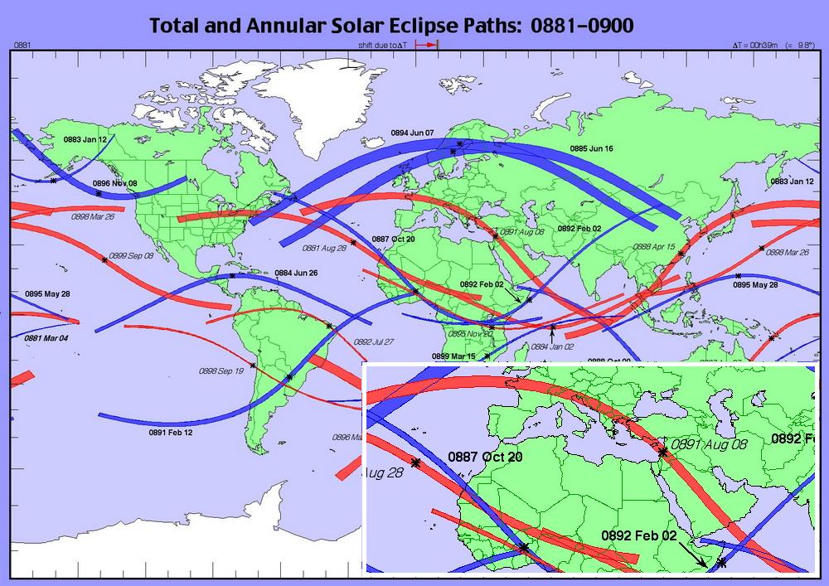

Figure No. 7. Map of Annular Solar Eclipse of March 18, 1010, 94th Saros.
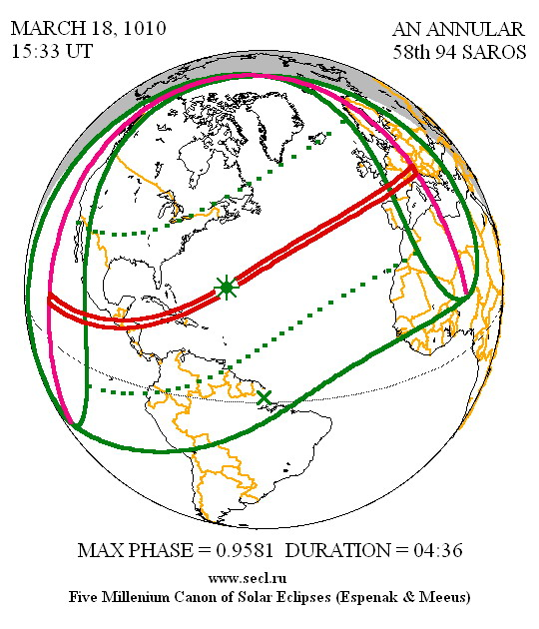
Another Biblical celestial phenomenon was an unusual Solar Eclipse at the time of the Crucifixion of Jesus Christ (birth 979/980 [5, 8]). We are talking about the hours of darkness that enveloped the Mediterranean in the afternoon. We have shown above that there are no suitable Solar Eclipses around the zero date of the Christian era. However, on March 18, 1010 there was an Annular Eclipse, during 4:36 minutes at 15:33 UT or 18:33 Constantinople time, 94th Saros, Figure No. 5 and 7 [10,11].
The celestial phenomenon was observed in Europe and the Mediterranean, up to Palestine. The accompanying effects of the Eclipse were unique, as the moon's shadow moved from southwest to northeast almost along the latitude in the final section. The disk of the sun was not yet obscured by the moon, but the darkness was beginning to thicken because of the penumbra. As a result, the Eclipse itself in Europe, the regions of Constantinople and Palestine occurred at the time of sunset after 18 o’clock of local time [8]. After sunset, the moon's penumbra deepened the gloom. The Solar Eclipse on March 18, 1010 occurred three days before the vernal equinox, which is contrary to Christian Easter traditions, but the Jewish Passover is possible until March 21. The resurrection of the Savior in this case falls on the day of the equinox, so from an astronomical point of view it is an accurate marker for determining the day of the annual celebration of Christian Easter.
According to the author's reconstruction of history [5, 8], the Lord Jesus Christ died for the second time in his earthly life in July, 1054 and possibly in the May, 1054 in Shandong, China. The death of the Savior was marked by a colossal celestial phenomenon – on this day the light from the explosion of a Supernova, now observed as a Crab Nebula, reached the Earth. Note that the flash of a Nova star means its death, not its birth. Three Chinese and one Armenian Texts indicate that the Supernova appeared in May shortly after the Total Solar Eclipse of May 10, 1054.
The Solar Eclipse and Supernova flare in 1054 is good marker for dating the Chronicles of Russia and the Byzantine Empire. The Primary Chronicle describes these two rarest phenomena in 1065 [18]. Similar information is also contained in the Novgorod Chronicle for 1065 [19].
It turns out that either the Dating of the Russian Chronicles of the XI century has a shift of 11 years forward, or this information was mistakenly attributed to the chroniclers in 1065. Quote [18]:
“At the same time there was a sign in the West, a great star, with rays like blood; in the evening it rose to the sky after sunset, and so it was for seven days”
At the same time, the chronicle notes that before this celestial phenomenon there was a Solar Eclipse [18]:
“Before that time, the sun also changed and did not become bright, but it was like a month, such a sun is said by the ignorant to be eaten”
If the Supernova explosion occurred in 1054 in July, then before the flash there was a Total Eclipse on May 10, 1054, visible in India and China, during 03:02 minutes at 07:16 UT, 103th Saros, Figure No. 8 [10,11]. It is also possible that we are talking about an Annular Eclipse on November 13, 1053, visible in the Volga region, India and China, during 07:44 minutes at 05:49 UT, 98th Saros, Figure No. 8 [10,11]. It should be understood that the New Year in the past started in September, so November 1053 and July 1054 fell on the same calendar year.

Figure No. 8. Total Solar Eclipse on 10.05.1054, 103th Saros, Annular Solar Eclipse on 13.11.1053, 98th Saros, and Annular Eclipse on 19.04.1064, 94th Saros.
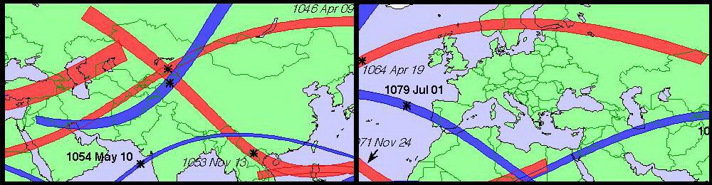

Note that in 1064 there was only one Annular Solar Eclipse, well observed in Russia for a period of 33 years. It is about an Eclipse on April 19, 1064, lasting 3: 58 minutes at 12:54 UT, 94th Saros, Figure No. 8 [10,11].
Probably, information about the rare pair of celestial phenomena in 1054 was included in the Russian Chronicles from China, since the phenomenon was associated with the passing of Jesus Christ.

Figure No. 9. The Annular Solar Eclipse of January 27, 632, 99th Saros.
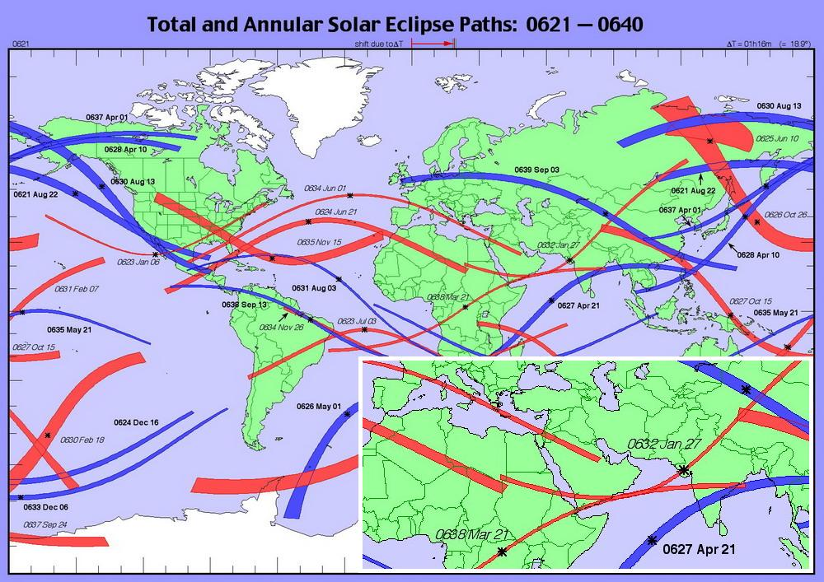

The final Biblical celestial phenomenon refers to the day of the death of the son of the Prophet Muhammad 28 Shawwal on the Islamic calendar. The Prophet himself died a few months after this tragedy. On the day of little Ibrahim's death, there was a Solar Eclipse. Traditional history dates it to January 27, 632 (28 Shawwal, 10 AH) based on calculations by astronomers. The 99th Saros Annular Eclipse during 1:40 minutes with a maximum over India at 06:45 UT or 12:15 o’clock local time. The width of the shadow was narrow – only 78 km and it moved along the tip of Arabia 1,100 km South of Medina at sunrise around 7:30 o’clock local time. Such a nondescript Eclipse could simply not be noticed, Figure No. 9 [10,11]. However, Muslim commentators did not mention that this was a partial Eclipse.
In accordance with the author's reconstruction of history [5, 8], the personality of the Prophet Muhammad became an integration of two historical figures – Khagan Kubrat from the VII century and Muhammad from the XII century. The lifetime of the Prophet Muhammad is 1090–1152. Surprisingly, on 28 Shawwal 546 AH is February 07, 1152, there was a powerful Annular Solar Eclipse with a phase of 0.924 at 11:15 UT, during 9:18 minutes, a shadow width of 288 km, the 107th Saros. The maximum phase of the Eclipse was clearly visible in Medina on the afternoon, Figure No. 10 and 11 [10,11].
Previously, we have shown [8] that the Holy Quran in the form of a full-fledged book appeared only in the 1160s. It was then that the custom of swearing on the Quran arose. For the first time in Chronicles, the oath on the Quran is recorded in 1178 in Volga Bulgaria [8]. Ibn Qudamah wrote an entire treatise on the benefits of swearing in the Quran in the 1170s. Therefore, our reconstruction of the time of the life of the Prophet Muhammad (1090–1152) and the writing of the Quran (1130–1152) is true. In addition, Jesus Christ acted in the XI century before the appearance of Muhammad, so the Prophet could not live in the VII century.

Figure No. 10. Annular Solar Eclipse of February 07, 1152, 107th Saros.
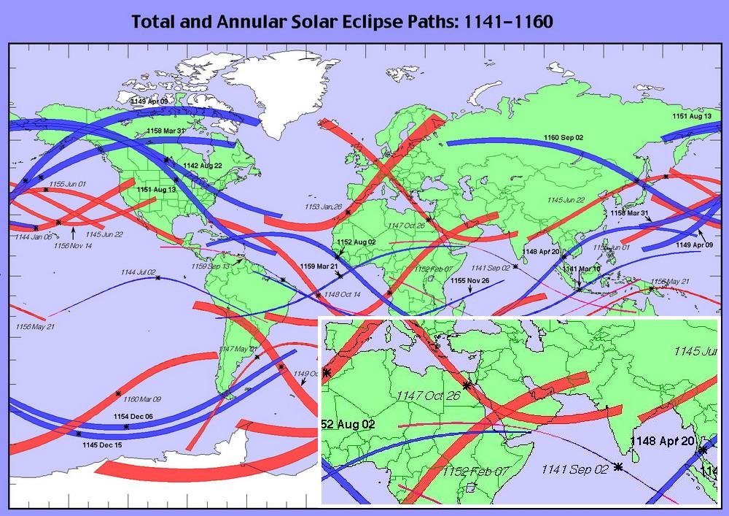

Figure No. 11. Map of Annular Solar Eclipse of February 07, 1152, 107th Saros.
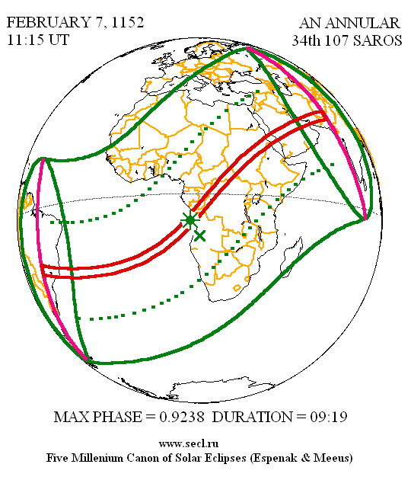
The results of our study of the Earth's civilization over a period of 2400 years from the Late Bronze Age collapse – the Flood of 1250–1200 BC to the acts of the Prophet Muhammad and the appearance of the Quran in the XII century are summarized in the Table No. 2. The Shift 1 column is the difference of events in years with the dates of the author's reconstruction, and the Shift 2 column is the difference of events in years with the dates of the traditional chronology.

The Table No. 2. Dating of celestial phenomena and events in history.
No. | Celestial phenomenon | Event in a history | Shift 1 | Shift 2
1 | The Zodiac and Total Eclipse 18.04.1178 BC, at 09:13 UT, 39th Saros | The end of Trojan War, returning Odysseus and start history of Egypt | 4 | 4/1780
2 | Annular Solar Eclipse, 15.09.339 BC at 06:53 UT, 58th Saros | Consecration of Juno Temple, is visible only in Volga region, Livy [12] | 0 | 0
3 | I century BC – I century, is not present suitable Solar Eclipses | Traditional date of the Crucifixion of Jesus Christ (33 year old) | 977 | 0
4 | Annular Solar Eclipse on February 24, 453, at 15:42 UT, 76th Saros | Joshua 's gains, aka Attila, capture of the Aquileia city | 0 | 1660
5 | Round and Long Zodiacs of Dendera of Pharaoh Ramesses II and Pharaoh Merneptah | The first turn of erection of Temple of goddess Hathor (540) and the second turn (568) | 0 | 1780
6 | Annular Solar Eclipse on January 27, 632 at 06:45 UT, 99th Saros | Death of Ibrahim the son of Prophet Muhammad, 28 Shawwal, 10 AH | 520 | 0
7 | Annular Solar Eclipse on August 08, 891at 10:23 UT, 98th Saros | 15th year of board of Pharaoh Takelot at alive father Pharaoh Osorkon | 1 | 1780
8 | Annular Solar Eclipse on March 18, 1010 at 15:33 UT, 94th Saros | Jesus Christ's Crucifixion on Mountain Bejkos, Galatia, Constantinople | 0 | 977
9 | Total Solar Eclipse on May 10, 1054 at 07:16 UT, 103th Saros and Supernova (M1) | Death of Jesus Christ terrestrial life in China from an old age, province Shandong (1054) | 0 | –
10 | Total Solar Eclipse on May 10, 1054 at 07:16 UT, 103th Saros and Supernova (M1) | Two celestial phenomena, The Primary Chronicle [18], 6573 (1065) | 11 | 11
11 | Annular Solar Eclipse on February 7, 1152 at 11:15 UT, 107th Saros | Death of Ibrahim the son of Prophet Muhammad, 28 Shawwal, 546 AH | 0 | 520

In total, we studied 15 celestial phenomena, including 11 Solar Eclipses, 3 Zodiacs, and 1 Supernova flare.
On Figure No. 12 we have drawn a chronological diagram of Biblical events and monotheistic religions [8] with markers in the form of squares of celestial phenomena and numbers of events from 1 to 11 according to the Table No. 2.

Figure No. 12. Chronological diagram of monotheistic religions [8].
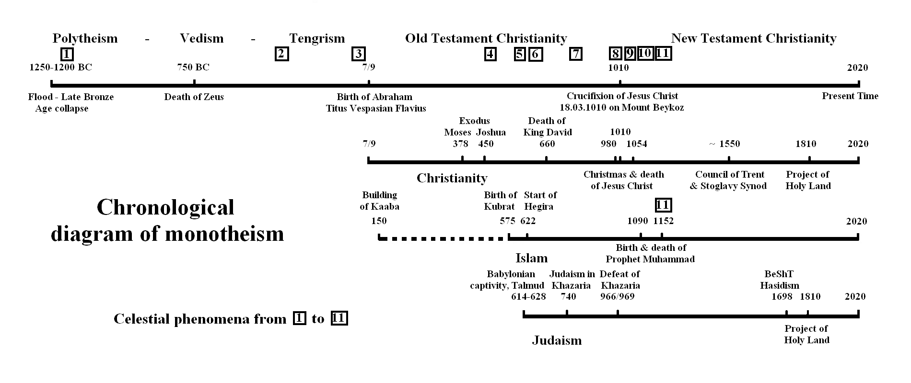

Conclusions of our research: The author's reconstruction of the history and chronology of religions [5-8] is fully verified by identifying 15 celestial phenomena described in the Chronicles, including 11 Solar Eclipses, 3 Zodiacs, and 1 Supernova flare. A chronological shift of 1780 years in the history of Ancient Egypt has been confirmed for 6 phenomena, including 3 Solar Eclipses and 3 Zodiacs. Astronomically confirmed the date of the Crucifixion of Jesus Christ as March 18, 1010 and the date of death of Ibrahim is the son of the Prophet Muhammad as February 7, 1152 (28 Shawwal, 546 AH). The author has compromised traditional historians ' references to 3 celestial phenomena as erroneous. The Solar Eclipse by Livy in 339 BC coincides in the author's and traditional chronology. The remaining 11 celestial phenomena are not identified in traditional history and chronology, so they are ignored by historians.

Pr. Dr. Valeriy Viktorovich Kubarev, 20.02–31.03.2020.
The full text of clause under the link: http://www.kubarev.ru/en/content/502.htm

Bibliography:
1. Gimbutas, M. (1964) Bronze Age Cultures in Central and Eastern Europe. Mouton.
2. Gimbutas, M. (1977) The first wave of Eurasian steppe pastoralists into Copper Age Europe. J. of Indo–European Studies, vol. 5.
3. Gimbutas, M. (1974) The God and Goddesses of Old Europe. 7000–3500 B. C.
4. Gimbutas, M. (1980) The Kurgan wave № 2 (c. 3400–3200 B. C.) into Europe and the following transformation of culture. J. of Indo–European Studies, vol. 8.
5. Kubarev V.V., Vedas of Russ, IP MEDIA, M., 2009. ISBN 9781-93252567-0.
Link: http://www.kubarev.ru/en/content/251.htm
6. Kubarev V.V., Short Chronology of Ancient Egypt, EESA, #6 (46) 2019, Part. 4, pp. 30–58.
7. Kubarev V.V., Localization of Ancient Rome, EESA, #7 (47) 2019, Part. 4, pp. 28–59.
8. Kubarev V.V., Chronology of monotheistic religions, EESA #8 (48) 2019, Part. 6, pp. 31–67.
9. Marcelo O. Magnasco, Constantino Baikouzis. Proceedings of the National Academy of Sciences, 2008. Link: https://www.pnas.org/content/105/26/8823
10. Fred Espenak, NASA/Goddard Space Flight Center.
11. Catalogue of solar eclipses. Links:
http://www.secl.ru/eclipse_catalog.html
http://astro.uni-altai.ru/HC/eclipses/solar_eclipses.html
12. Titus Livius, VII, 28.
13. Colin Humphreys, Graeme Waddington, Solar eclipse of 1207 BC helps to date Pharaohs , Astronomy & Geophysics, Volume 58, Issue 5, October 2017, Pages 5.39–5.42. Link: https://academic.oup.com/astrogeo/article/58/5/5.39/4159289
14. M. Liverani, «The collapse of the Near Eastern regional system at the end of the Bronze Age: the case of Syria», in Centre and Periphery in the Ancient World, M. Rowlands, M.T. Larsen, K. Kristiansen, eds. (Cambridge University Press) 1987.
15. The Chronicle of Theophanes Confessor.
16. Ginzel F.K. 8 Specieller Canon der Sonnen — und Mondfinsternisse, Berlin, 1889, pages 260–262.
17. Морозов Н.А., Христос. Т.6. — М–Л.: ГИЗ, 1930. Стр. 758–762.
18. The Primary Chronicle. Tale of Bygone Years, 6573 (1065).
19. The Novgorod First Chronicle, Senior and Junior text, 6573 (1065).

Kubarev V.V., Astronomical dating of Biblical events, EESA #3 (55) 2020, Part. 2, pp. 24–35. Link:
https://eesa-journal.com/wp-content/uploads/EESA_3_55_march_2020_part_2.pdf

